The Shipwright
2007 Past Grand Knights’ Dinner
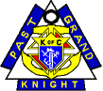

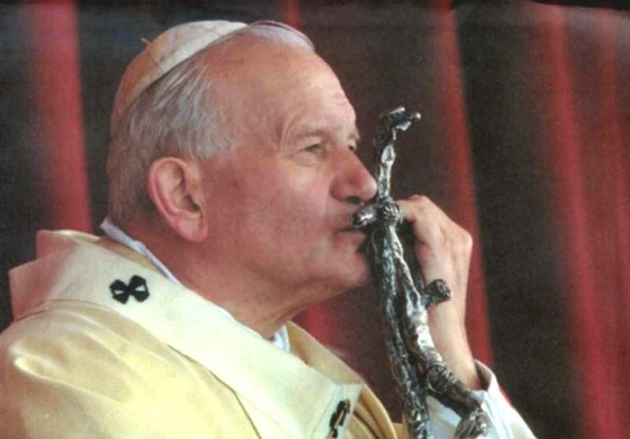
Knights of Columbus
John Paul the Great Council 486
Middletown, New York

Welcome Past Grand Knights!

Dear families and friends,
December is the month in which we celebrate the birth of Jesus Christ, our Savior. It is also a time to honor the leadership of many who have served the Knights of Columbus in the capacity of Grand Knight, a position entrusted to them by our members throughout the nearly 108 years of our existence. These men gave of themselves and worked hard to contribute to the ultimate success of our Council. These were men who realized that a prayer life, and trust in God’s Will, was crucial to their being. They had the foresight to set the goals, and then provided the leadership and motivation to achieve them. Often it was a difficult road, and I’m sure they felt alone in many of the difficult decisions they had made. But they soon realized that our membership was behind them, supporting them and ready to take on the challenges that we all faced. And while they were pleased with their accomplishments, they were humble enough to realize that our Lord was ultimately responsible.
And so, from all of us, we wish to say THANK YOU for your service to us.
To all of our families and loved ones, my family and I would like to take this opportunity to wish all of you, a truly blessed and holy Christmas Season.
God Bless,
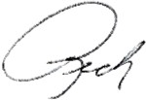
Rich Trapani
Grand Knight

Council Officers

Chaplain
Rev. Dennis Nikolic

Grand Knight
Richard Trapani, Jr.

Deputy Grand Knight
Gregory Sillen

Chancellor
Michael Biondi

Warden
Douglas Linguanti

Recorder
Paul Dickinson

Financial Secretary
Jim Higgins

Treasurer
Larry Bedosky

Advocate
John O’Connor, PGK

Inside Guard
Christopher Pratti

Outside Guard
Edwin Diaz

Trustee 1st Year
Joseph Hartmann, PGK

Trustee 2nd Year
Matthew Enering, PGK

Trustee 3rd Year
Carl Williams, PGK

Lecturer
Deacon Richard Trapani, Sr.

Insurance Agent
William Schimpf FIC

District Deputy
Burton Struble PGK

T. Frank Cullinan*

J. Edward Dever*

Charles A. Landy*

Frank W. Lane*

Joseph J. Kennedy*

Edmund C Faulkner*

Patrick J. E. O'Brien*

Patrick P. Connors*

Frank Monaghan*

Renfred J. Rogers*

Robert F. Cunningham*

George J. Welch*

John D. Botti*

Ralph J. Marasco*

John J. Cullinane*

Frank J. Hamilton*

Charles F. Stride*

Raymond Keener*

Alfred Schubert*

Edward J. Carey*

* Deceased
F. Ambrose Taylor*

Thomas F. McMahon*

William Pape*

Roland F. Larkin*

Joseph J. McGuigan

George P. Ellis

Herman Wolkenberg*#

Frank D. Blizard, Jr.

Richard C. Brisky

John J. O'Connor

W. Norton Madigan

Frank P. Griffin*

William R. Myers

William L. Moore*

Gerard J. Hamm*

James J. Garland*

Frank Vignola

Wesley R. Sontag

Clyde J. Cutler*

Nicholas J. Cortese+

# Past NY State Deputy
John C Auty

Louis C. Scarano+

John Crofoot*

Seamus Murphy*

Thomas Moore*

Emanuel P. Gallea*

Frank Musmeci*

John P. Crowe, Jr.

Ralph Russo*

Anthony J. Ingrassia

Thomas J. Shormis

Louis J. Curcio

Steven S. Malieke

Matthew Enering, Sr.+

Michael F. Amodio, Jr.

Paul Silipino

Burton Struble

Carl R. Williams, Sr.

Michael F. Cummings

Joseph M. Hartmann

+ Served as Grand Knight more than once
Past Grand Knights

